Orsolino, Abigail A.

CITCS-1C

**Packet Tracer - Skills Integration Challenge**

**Addressing Table**

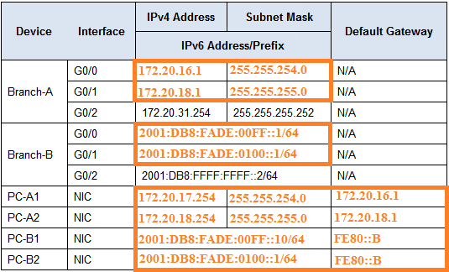

**Requirements**

·         Configure the initial settings on **Branch-A**and **Branch-B**, including the hostname, banner, lines, and passwords. Use **cisco** as the user EXEC password and **class**as the privileged EXEC password. Encrypt all passwords.

·         LAN A1 is using the subnet 172.20.16.0/23. Assign the next available subnet to LAN A2 for a maximum of 250 hosts.

·         LAN B1 is using the subnet 2001:DB8:FADE:00FF::/64. Assign the next available subnet to LAN B2.

·         Finish documenting the addressing scheme in the **Addressing Table** using the following guidelines:

-       Assign the first IP address for LAN A1, LAN A2, LAN B1, and LAN B2 to the router interface.

-       For the IPv4 networks, assign the last IPv4 address to the PCs.

-       For the IPv6 networks, assign the 16th IPv6 address to the PCs.

·         Configure the routers addressing according to your documentation. Include an appropriate description for each router interface. **Branch-B** uses FE80::B as the link-local address.

·         Configure PCs with addressing according to your documentation. The DNS Server addresses for IPv4 and IPv6 are shown in the topology.

·         Verify connectivity between the IPv4 PCs and between the IPv6 PCs.

·         Verify the IPv4 PCs can access the web page at **central.pka**.

·         Verify the IPv6 PCs can access the web page at **centralv6.pka**.